November 29, 2025
Shreyes Balachandran
Prof. Chris Piech
CS 109
CS 109 Probability Challenge: How Representative are our Institutions?
Abstract
In my personal challenge, I explore how representative our elected institutions, the Presidency and the House of Representatives, are of the popular vote. Collecting data from elections from 1856-2024, I consider representation as a probabilistic relationship from two-party popular vote share to results, either the electoral vote or seats won. I first use maximum likelihood logistic regression to determine the likelihood of electoral victory given different popular vote totals. To analyze the relationship between popular votes and results, I fit a Bayesian regression model to estimate the expected share of the electoral college won conditional on the popular vote. Finally, I compute the KL-divergence between popular vote and result distributions to establish a numerical measure of proportionality for each election, allowing me to compare the representativeness of both institutions and of each institution over different periods of time. One major limit of my analysis is that I normalize elections into two-party contests, which is not always an accurate representation; furthermore, it does not look at states or House districts. My analysis offers an insight into the degree to which each voter actually participates in our democracy.
Introduction
Public satisfaction with American democracy is lower than ever. A major reason for this is the pervasive belief that one’s vote does not matter, as two presidential elections in the current century have failed to reflect the popular vote and gerrymandering lowers the number of competitive seats. My project seeks to understand to what extent our electoral system inhibits the expression of individual votes using probabilistic methods. I also hoped to observe the difference in biases between the House and the Presidency to determine which institution was more representative.
I set out to answer the following questions. Given a party’s popular vote share (compared to the main opposition party), what is the probability that they win the Presidency and House? Given a party’s popular vote share, what is the expected value of their share of the electoral vote? Which institution is most likely to reflect the popular vote? And finally, has representativeness changed over the time frame 1856-2024 with respect to accuracy to the popular vote?
Data
I collected the popular vote and results of the Presidential and House elections from 1856-2024. I chose this time frame because 1856 was the first Republican vs Democrat election, which provided my data consistency (I did not have to respond to the collapse of a party). I excluded the Senate because the Senate only elects ⅓ of its members at a time and is also designed to be imperfectly representative of the popular vote. I was unable to find reliable data for the popular vote for House and Presidential elections (although the results were available in online atlases) in a database. As such, I relied on Wikipedia figures, which may include some inaccuracies. For instance, the 1904 election has the Republican to Democrat proportions at exactly .6 to .4, which I find improbable; nevertheless, I used it as the best available data. After collecting this data, I normalized it by assuming the election was a two-party contest and taking the vote for each party divided by the total vote for both parties for each type of vote (popular, electoral, congressional). Given the exclusion of third party votes, this could inject bias into the model; it was preferable to including ephemeral factions in long-term data.
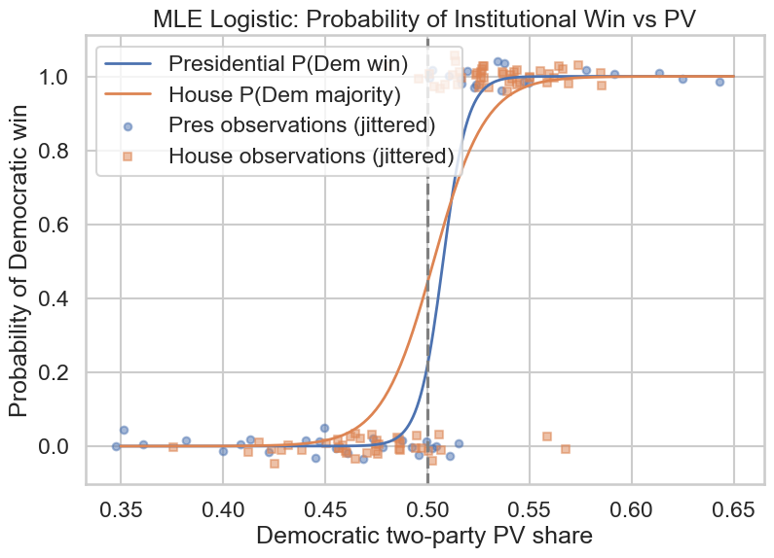
Logistic Regression: Likelihood of Electoral Victory Given Popular Vote
Because logistic regression offers a binary result given a factor, I used it to predict the likelihood of electoral victory (EV₁ > EV₂) given the Democratic two-party popular vote. If v_{i} = Democratic two-party popular vote in election i, then Pr(Win|v_{i}) = σ(β₀+β₁v_{i})=1/(1+e^{-(β0+β1vi)}), where β₀ is the intercept and β₁ the slope of the model. Then L(β₀, β₁)=the product of this expression over all elections i. I used maximum likelihood estimation to estimate the parameters β₀ and β₁ for both the Presidency and the House. My code found that for the Presidency, the intercept was -84.69, and the slope 166.78; for the House, the intercept was -39.5 and the slope 78.51. Both graphs are flat at 0, then ascend rapidly towards 1, then slow down rapidly, and are then flat at 1. Since the House has lower magnitude parameter values, it ascends more gradually, and is less sensitive to marginal popular vote changes than the Presidency. Presumably, since there are 435 districts for the House compared to 50 states in the Electoral College, the effects of small changes in the popular vote are more balanced in the House. Additionally, the flip-point for the Presidency is 84.69/166.78=.5078, while for the House it is 39.5/78.51=.5031; in other words, P(Presidential win|v_{i}=.5078)=P(House win|v_{i}=.5031)=.5. Since the House flip-point is closer to .5, this indicates again that the House is more representative than the Presidency.
Bayesian Regression: Expected Electoral Votes Given Popular Vote
To evaluate the relationship between popular vote share and result vote share, I fit Bayesian linear regressions predicting Electoral College vote share (for the Presidency) and seat share (for the House). Posterior means provide estimates of the intercept and slope, reflecting the average responsiveness of each institution to shifts in popular support. I compared both Bayesian lines to OLS linear and quadratic regression lines to assess the true relationship.
For the Presidency, the quadratic model seems more accurate as it observes a strong winner’s benefit, since electoral vote share rapidly grows above about 52% of the popular vote. This indicates Bayesian linear regression is a poor fit for the task. For the House, the linear Bayesian model seems to work better. As in the logistic regression, this is probably because of the effect of 435 districts vs 50 states, making the graph less volatile to popular vote changes.
KL Divergence: Comparing Representativeness over Institutions and Times
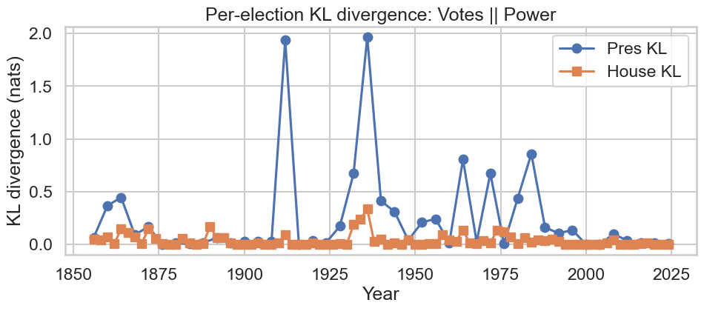
I used KL Divergence to score the representativeness of each election, then sorted them into groups based on institution and party system to make comparisons (KL Divergence here is more useful to show comparative representativeness as opposed to objective representativeness). We have two probability distributions: the popular vote distribution can be described as a set (p, 1-p), and the results as a set (v, 1-v). Then we compute KL divergence: D_{KL}(v||p)=vlog(v/p)+(1-v)log((1-v)/(1-p)). I did this for each election, then found the mean and median for both the Presidency and House. I also measured each institution’s divergence over party systems. I defined the Party Systems as: Third (1856-1892), Fourth (1894-1928), Fifth (1930-1972), Sixth (1974-2024) inclusive. These party systems each reflect a relatively consistent political system, and their intersections points of political upheaval. The Presidential elections had mean KL .2503, median .0630; the House had mean KL .0379, median .0121. In both cases the mean was raised by outlier landslides where one party won a decisive electoral victory, however this was much more pronounced in the Presidency. For instance, visible in the Per-election KL Divergence graph are the Presidential elections of 1912 and 1936, where the results were respectively 435-8 and 523-8 in a two-party contest; given that the popular votes were not nearly so skewed, this resulted in a very high divergence score. It seems clear from these results that the House is more representative than the Presidency. We also found that the Fourth Party System (Progressive Era) saw the most representative government in both the Presidency and House, while the Fifth saw the least representative Presidency and the Third the least representative House. Interestingly, the Sixth Party System (current) appears more representative in both the House and Presidency than the Fifth Party System, which I did not expect.
Summary & Conclusion
We find that both the House and the Presidency are generally but not entirely representative of the popular vote, as many exceptions exist. We find that overall, the House appears to be more representative of the popular vote than the Presidency, with the effect being exaggerated during landslides, which are much greater in the Presidency than in the House. It also appears that Bayesian linear regression is a mediocre method for measuring the effect of popular votes on electoral votes. KL Divergence seems to be a more distinctive method of understanding the difference between the Presidency and House than logistic regression, but it is worse for an objective understanding of representativeness.
My project offers individuals a chance to understand the worth of their vote (it seems voting in the midterms might actually be a better use of your vote than in the Presidential elections). It suffers from several serious limitations, such as the lack of attention to states/districts, the heavy-handed normalization which ignores all third-party votes, and the use of linear regression when that seems clearly a poor fit for the task.
Use of AI
I used AI to, once I had come up with my research questions, determine which probabilistic methods would make the most sense to answer them. I also used it to help me generate code for plotting for my methods, although the plans and code to create the models for the plots was done by me. I attempted to use it along with Kaggle and websearching to find the data I wanted, but as I explained above was not successful.
Appendix A
This links to a sheet containing the electoral data.
Appendix B
These are additional graphs generated by my code.

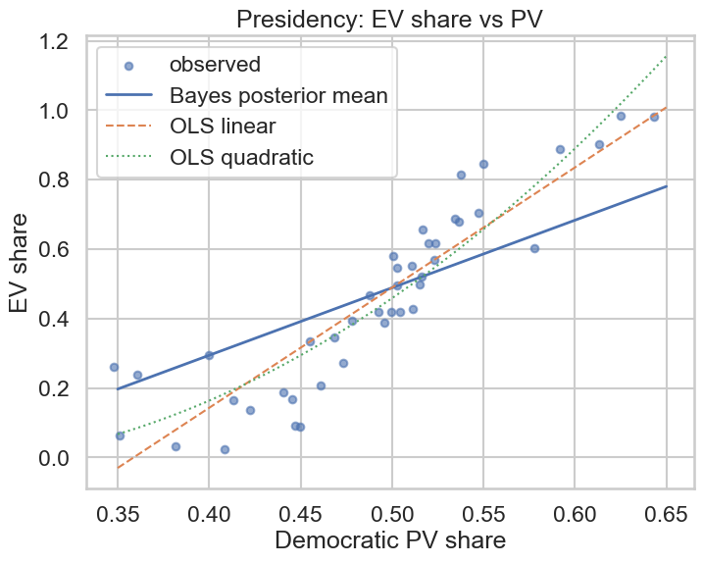
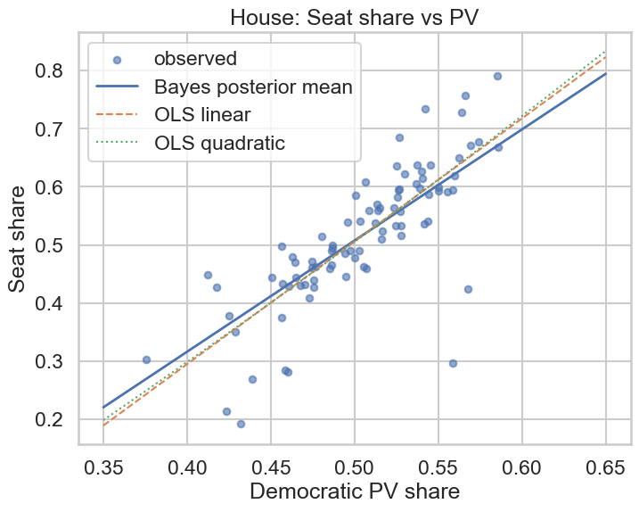

These graphs (for Presidency and House respectively) have the Bayesian regression, OLS linear regression, and OLS quadratic regression trendlines for the dataset.

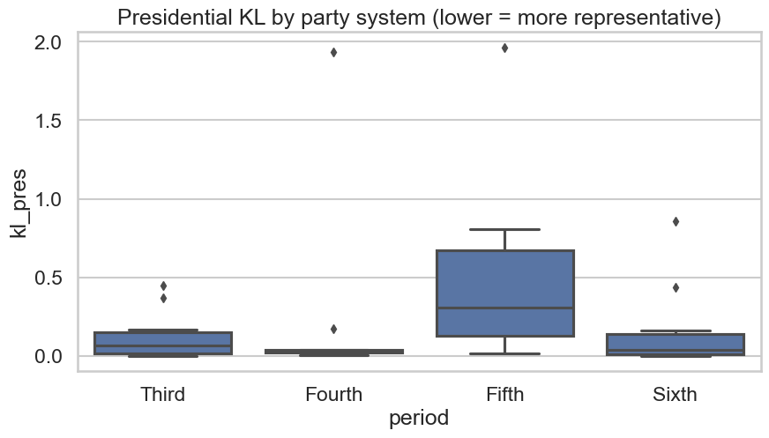
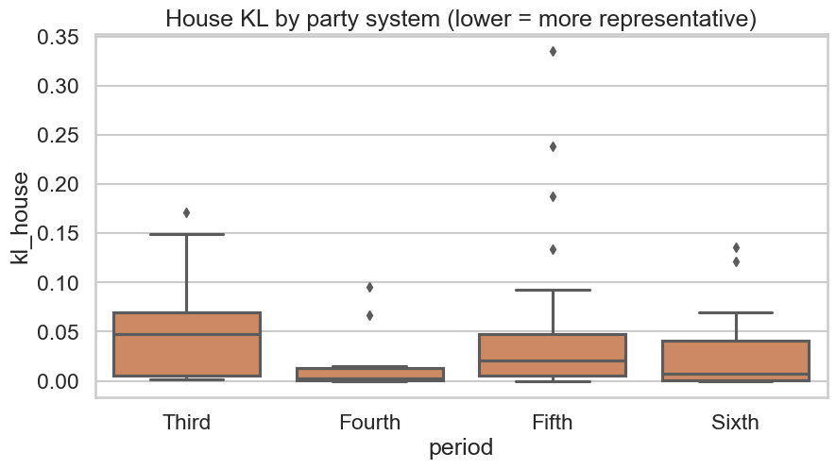

This is the range of KL-divergence over each party system for the Presidency and House.

